CAMPAIGN AGAINST NMBI FEE INCREASE

Social Media Event - Picture Protest -

THUNDERCLAP

Wednesday, 17th December 2014 starting at 12.00 noon

Dear Colleague

As a further strand, of our ongoing campaign of opposition to the proposed retention fee increase from NMBI, our three unions are organising a social media, workplace based, event (known as a Thunderclap), to take place anytime between 12.00 noon on Wednesday, 17th December 2014 and 3.00 p.m. on Friday, 19th December 2014.

This event is shaped to increase awareness, amongst the general public, and to visibly show all politicians, in this country, that nurses and midwives are not going to pay this 50% increase but will continue to pay the current €100 fee.

On Wednesday, 17th December 2014, after 12.00 noon, this “Thunderclap” is planned for all work locations, around the country, and will allow every nurse/midwife, in that workplace, to demonstrate their solidarity with this campaign. Once the event is captured, from each individual workplace, it will create a massive visual presentation, of opposition to the fee increase, from every workplace across the country.

In order to ensure all events are captured, and sent to unions, I now draw your attention to the step by step guide to your workplace participation in this “Thunderclap”.

1. This notice is attached to posters conveying the required message.

2. Simply fill in, in BOLD, BLACK, FELT TIP MARKER, the name of your workplace in the space provided and present the message as in the photo below.

3. In workplaces where members belong to different unions you are all asked to come together to create this workplace protest/Thunderclap.

4. For anybody who does not have a Twitter or Social Media account please send your picture to deanflanagan@inmo.ie to be published and included with your colleagues around Ireland.

5. Log in to your Twitter account with your username and password. If you have not created a Twitter account yet, sign up.

Add @INMO_IRL and @SIPTUIreland as a friend to follow.

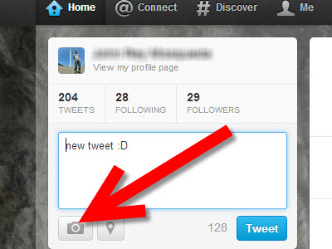

6. Type a new tweet into the box labelled "Compose new Tweet." This can be found on the left-hand side of the "home" screen.

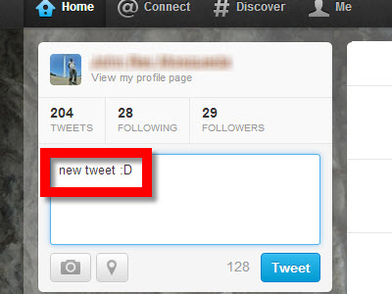

7. Click on the greyed-out icon that depicts a camera located below your tweet on the left. A pop-up window will display prompting you to upload a photo from your computer or phone.

8. Choose the photo you want uploaded from your computer/phone into Twitter. Click on your photo to select the image and have it added to your tweet. Your image will appear below your tweet in the size of a thumbnail and the camera icon will now be blue.

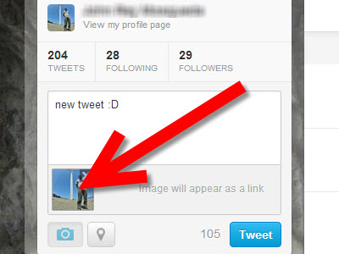

5. Click on the "Tweet" button to publish your photo to Twitter. Your friends and followers will now have the ability to view your photo after clicking on its link in your tweet.

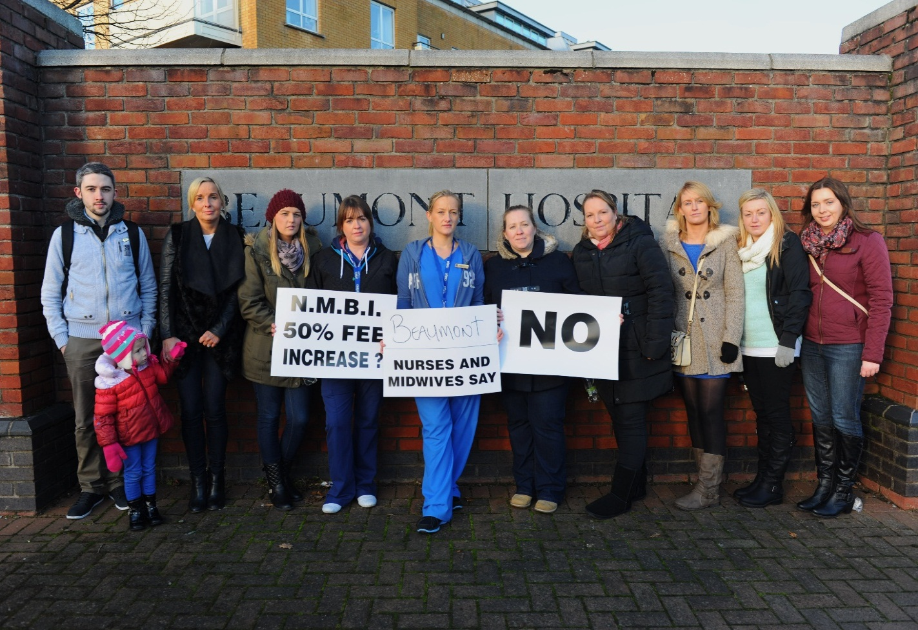

REMEMBER TO SEND YOUR PICTURE TO THE @INMO_IRL and @SIPTUIreland Twitter Pages for this campaign and include #PNA and #No2NMBIincreases.

Solidarity

Please ensure your workplace, in the form of every available nurse or midwife, after 12.00 noon on next Wednesday, 17th December 2014, participates in this campaign and send us your Thunderclap - Picture Protest.

Our three unions will then highlight this nationwide demonstration of solidarity, to the campaign, to all other stakeholders and, particularly, NMBI and the wider political system.

This is a simple, straightforward but effective opportunity to demonstrate that every workplace, is fully supportive of, and committed to, this campaign.

JOIN IN

SEND US YOUR PICTURE AND
LET THE CAMPAIGN CONTINUE TO GROW

In addition to this day please watch out for further updates in relation to all developments as this campaign continues.

Yours sincerely

LIAM DORAN KEVIN FIGGIS DES KAVANAGH
General Secretary National Nursing Officer General Secretary
INMO SIPTU PNA

