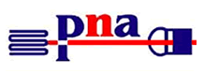
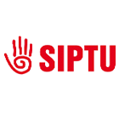
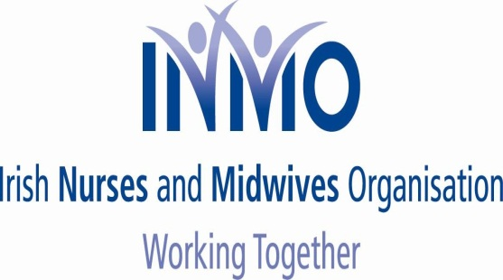

NEWSFLASH NO. 15

Tuesday, 16th December 2014

CAMPAIGN OF OPPOSITION TO NMBI FEE INCREASE

Dear Member

In relation to this campaign we remind you of the following:

1. Wednesday, Thursday, Friday, 17th, 18th, 19th December 2015

All members, in all workplaces, reminded to join in the nationwide workplace social media picture protest, confirming your workplace’s support for our campaign, to take place over the next three days. Check previous updates for details or your union’s website. We want visual wall of opposition so upload your picture and make sure your workplace is included.

2. The NMBI special board meeting last Friday, 12th December 2014 did not result in any new developments. We understand, further contacts continue with the Department of Health.

3. Cancel your direct debits, if you have not done so, as per previous advice.

4. Pay €100, after 5th January 2015, or when your personal circumstances allow. Payment to be made via cheque, postal order or credit transfer (bank details available from your union).

No-one has to pay by 1st January, ignore recent statements from NMBI which, regretfully, continue to be threatening and misleading.

STAY LOYAL AND SUPPORTIVE OF THE CAMPAIGN.

Yours sincerely

LIAM DORAN KEVIN FIGGIS DES KAVANAGH
General Secretary National Nursing Officer General Secretary
INMO SIPTU PNA

