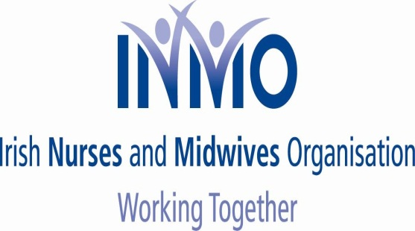

**NEWSFLASH NO. 11**

***Friday, 21st November 2014***

**CAMPAIGN OF OPPOSITION TO NMBI FEE INCREASE**

**FURTHER ADVICE RE PAYMENT OF FEE**

Dear Colleagues

Further to our on-going campaign please note the following;

1. In recent correspondence, from the Department of Health to the NMBI, it was **confirmed that no nurse/midwife can be considered, for removal from the register, for non-payment until April each year;**

* **This confirms there is no need, despite the intimidatory statements from NMBI, to pay any retention fee, in full, by the 01st January**;

1. **Our three unions are now advising members to make a payment of €100, covering their retention fee, to NMBI in the week beginning Monday 05th January and no later than Friday 09th January;**
2. Our three unions will shortly be circulating, to all workplaces, badges, which members can display on their lapel, confirming they have made this payment (€100) and continue to be a registered nurse/midwife;
3. In response to our letter NMBI has said it is cooperating fully with all requests to cancel direct debits.

* Therefore members should immediately advise their union of any difficulty as we continue to receive complaints on this matter (see further letter to NMBI).

REMEMBER

STAY UNITED - PAY €100 WEEK BEGINNING 05TH JANUARY

- MONITOR UPDATES

Yours sincerely

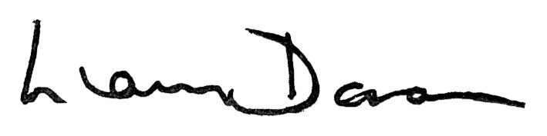

**LIAM DORAN KEVIN FIGGIS DES KAVANAGH**

**General Secretary National Nursing Officer General Secretary**

**INMO SIPTU PNA**