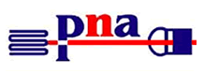
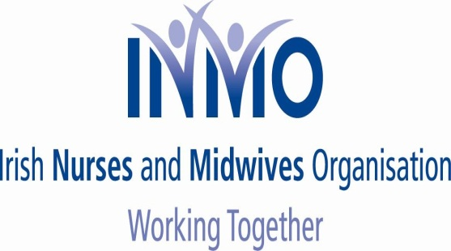
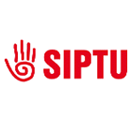

NEWSFLASH NO. 10

Wednesday, 19th November 2014

CAMPAIGN OF OPPOSITION TO NMBI FEE INCREASE

Re: CANCELLATION OF DIRECT DEBITS

Dear Colleague

Further to our on-going campaign of opposition, to the fee increase being sought by NMBI, we ask you to note the following:-

- In recent days all three unions have received numerous queries, from members, indicating they were experiencing difficulties, with NMBI, when they sought to cancel their direct debits;

- In response to this we now attach, for your attention and information, copy of letter, sent today, to the CEO of NMBI which is self-explanatory. We will advise you, immediately, when we receive a reply from the CEO;

- In addition to cancelling any direct debits, which remain in place, we continue to advise members to await direction, from our three unions, as to when to pay the existing €100 fee to NMBI;

- The NMBI Board is meeting again today. The President has indicated that he will update us on their position, re the fee, following discussions, on this issue, at today’s meeting. We will, of course, also advise you of any developments, and response from the Board immediately.

STAY UNITED - PAY €100 WHEN ADVISED
- AWAIT FURTHER UPDATES

Yours sincerely

LIAM DORAN KEVIN FIGGIS DES KAVANAGH
General Secretary National Nursing Officer General Secretary INMO SIPTU PNA

