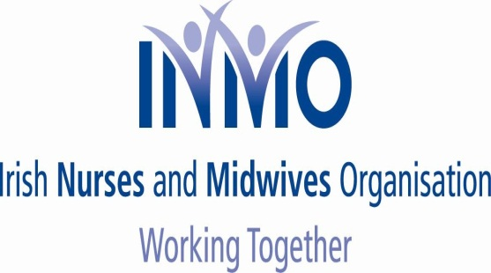

NEWSFLASH NO. 14

Friday, 12th December 2014

CAMPAIGN OF OPPOSITION TO NMBI FEE INCREASE

Dear Member

Once again, on behalf of our three unions, we wish to update you in relation to the ongoing, continuing and growing campaign of opposition to the proposed increase in the retention fee, for 2015, levied by NMBI by 50%.

In this regard please note the following:

1. We have been advised that the Board of the NMBI is scheduled to meet, in special session, tomorrow, Friday, 12th December 2014, to consider this fee issue and the problems now arising. We will advise you of any developments, arising from this meeting, as soon as we become aware of same.

2. As previously detailed the next step in our campaign is a social media - picture protest day - scheduled for every workplace, after 12.00 noon on next Wednesday, 17th December 2014. Posters, together with an information leaflet, have been sent directly to the majority of workplaces and your local representative should be in contact with you to arrange how your workplace can participate in this nationwide initiative.

- All pictures, uploaded, will be collated to create a visual wall confirming the solidarity of all workplaces to the campaign.

- In addition the visual pictures, from individual workplaces, will be sent to the local TDs/Senators.

3. We again reaffirm our advice that, after 5th January 2015, members should make a payment of €100, to NMBI, by one of the following three methods:

- cheque;
- postal order;
- credit transfer (NMBI bank details can be obtained from your union).

4. Once again, even at this late stage, if you have not cancelled your direct debit, to NMBI, then please do so immediately. Bank details can be accessed from your union. In addition if you are having any difficulties, with your bank in cancelling this direct debit, members can download a template letter, to be sent to your bank, from your unions website.

5. We again remind you that badges, confirming payment of the €100 and registration, will be distributed to workplaces in the early days of the New Year. Members will be asked to wear the badge, again as a visual demonstration of the campaign and the collective involvement of nurses/ midwives in workplaces.

6. Further updates will issue in due course. Remember:

CAMPAIGN CONTINUES TO GROW
NATIONWIDE SOLIDARITY IS GROWING
AWAIT FURTHER UPDATES

Yours sincerely

LIAM DORAN KEVIN FIGGIS DES KAVANAGH
General Secretary National Nursing Officer General Secretary
INMO SIPTU PNA

