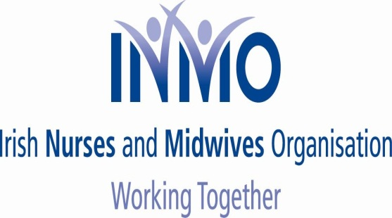

NEWSFLASH NO. 5

FOR THE ATTENTION OF ALL MEMBERS

Tuesday, 04 November 2014

Re: Nursing and Midwifery Board of Ireland (NMBI) - 2015 Retention Fee

Dear Member

We refer to our previous newsletters, in relation to the ongoing campaign of opposition to the NMBI proposed fee increase, and wish to advise you of the following:

1. NMBI Renewal Notices
We understand that NMBI has begun to issue renewal notices, with regard to registration, to nurses and midwives across the country.

All members are advised to make no payment to NMBI, at this time, and await further advice through your respective union.

This is to allow us assess developments, emerging from the matter being raised under Haddington Road and the subject of various meetings, which will, on an ongoing basis, be advised to you.

2. Payment of €100 Registration Fee
As our three unions have consistently pointed out we accept the need for a strong regulatory body, for nursing and midwifery. This Body should protect the public by ensuring nurses and midwives can practice in a clinical environment conducive to safe practice.

Consistent with this collective position we will advise you, in due course, as to when to forward your €100 fee for registration to NMBI. We will be asking that all payments are made in a manner that allows you keep a record of making this payment.

Obviously, even at this late stage, we would ask all members, who have not already done so, to immediately cancel their direct debit to NMBI so that no payment in excess of €100 is made.

3. Meeting with Department of Health/Haddington Road Agreement
As previously advised the attempt by NMBI to increase its fee by 50% during the term of the Haddington Road Agreement, was raised at the Oversight Body meeting last week.
All of the unions stressed that while supporting the €100 registration fee, paid by other allied health professionals, we were absolutely opposed to any further increase, incurring costs upon members, during a period where pay had been reduced.

Discussions/contacts are ongoing, with the Department of Health, on this matter, and members will be advised on an ongoing basis.

4. Public Protest - Tuesday, 18th November 2014
Members are again reminded that our three unions are holding a public protest outside the headquarters of the NMBI in Carysfort Avenue, Blackrock, at 12.00 noon on Tuesday, 18th November 2014.

Members are reminded, if travelling from outside of Dublin, to liaise with their local representatives to ensure transport arrangements are finalised in order to maximise attendance.

5. Nurse Managers
We also wish to advise you that we are writing, by separate letter, to Directors of Nursing/Midwifery/Public Health Nursing advising them, formally, of this campaign of opposition to a fee increase.

We will be asking them to respect this campaign in the context of seeking PIN numbers for 2015. We will also remind them that the final date, for paying the registration fee, is 31st March of each year. Therefore there is no necessity to seek PIN numbers before this date.

Summary

The two immediate next steps, involving all members, can be summarised as follows:

- When you receive your renewal notice you are asked to make no payment, at this time. Furthermore members are asked to wait further advice, from your unions, as to when a payment of €100 (the existing fee) should be made maintaining a record of such payment.

- Members should arrange to attend the public protest at 12.00 noon, outside NMBI HQ, on Tuesday, 18th November 2014.

Further updates will issue, in the coming days, and thank you for your attention to this note.

Yours sincerely

LIAM DORAN KEVIN FIGGIS DES KAVANAGH
General Secretary National Nursing Officer General Secretary
INMO SIPTU PNA

